To create a real estate app for East Africa inspired by the **RealForGoodApp** and platforms like **Domain.com.au**, here’s a breakdown of what you can learn from these sources and how to apply it to your local context:

**🔍 What Domain.com.au Offers (Key Features)**

Domain’s platforms like **Realhub** and **Campaigntrack** provide powerful tools for real estate professionals:

**Realhub**

* **Marketing Campaign Manager**: Helps agents manage listings efficiently.
* **Business Management Tools**: Offers oversight of staff productivity and marketing.
* **Branded Templates**: Ensures consistent visual identity across listings.
* **Supplier Integration**: Connects with 400+ real estate suppliers.
* **Digital Proposals**: Integrated with tools like Engage for client pitches.[[1]](https://agent.domain.com.au/residential/realhub/)

**Campaigntrack**

* **End-to-End Marketing**: Combines digital, print, signage, and social media.
* **Efficiency Tools**: Streamlines property marketing workflows.
* **Commercial Property Support**: Offers packages for different budgets.
* **Digital Reach**: Uses Google and Facebook ads to target buyers.[[2]](https://agent.domain.com.au/residential/campaigntrack/)

**🌍 Building a Real Estate App for East Africa**

Based on expert guides from Artkai and DignuzDesign, here’s how to build a localized version:

**1. Define Your App Type**

Choose based on your goals:

* **Property Search App**: For buyers and renters.
* **Property Management App**: For landlords and agents.
* **Real Estate Marketplace**: For listing and transactions.
* **Investment App**: For analyzing ROI and market trends.[[3]](https://artkai.io/blog/how-to-build-a-real-estate-app)

**2. Must-Have Features**

* **Advanced Search Filters**: Location, price, type, amenities.
* **Interactive Maps**: Use Google Maps or OpenStreetMap.
* **3D Tours & VR**: Optional but powerful for remote viewing.
* **User Accounts**: Save searches, favorites, alerts.
* **Messaging System**: Connect buyers with agents.
* **Multilingual Support**: Swahili, French, English, etc.
* **Offline Access**: Important for areas with limited internet.[[4]](https://dignuzdesign.com/blog/real-estate-web-app-development/)

**3. Tech Stack Suggestions**

* **Frontend**: React or Vue.js for flexibility and speed.
* **Backend**: Node.js or Firebase for scalability.
* **Database**: PostgreSQL (for geospatial data) or Firebase Firestore (for real-time updates).
* **Hosting**: AWS, Google Cloud, or local providers.

**4. Monetization Options**

* Featured listings
* Agent subscriptions
* Advertising (local businesses)
* Transaction fees

**💡 Local Adaptation Tips**

To make your app successful in East Africa:

* **Mobile-first design**: Most users will access via smartphones.
* **Low-bandwidth optimization**: Compress images, use caching.
* **Local payment integration**: M-Pesa, Airtel Money, etc.
* **Community features**: Allow reviews, neighborhood insights.
* **Partnerships**: Work with local agents, NGOs, and housing authorities.

Would you like help drafting a **feature roadmap**, **UI mockup**, or even a **prototype** using tools like FlutterFlow or Glide? I can also assist with setting up your tech team or finding open-source templates to get started.

**References**

[1] [Property campaign management platform | Domain Marketing Hub](https://agent.domain.com.au/residential/realhub/)

[2] [Full service real estate marketing platform | Domain Marketing Hub](https://agent.domain.com.au/residential/campaigntrack/)

[3] [How to Build a Real Estate App: A Complete Guide | Artkai](https://artkai.io/blog/how-to-build-a-real-estate-app)

[4] [How to Develop a Real Estate Web App - dignuzdesign.com](https://dignuzdesign.com/blog/real-estate-web-app-development/)

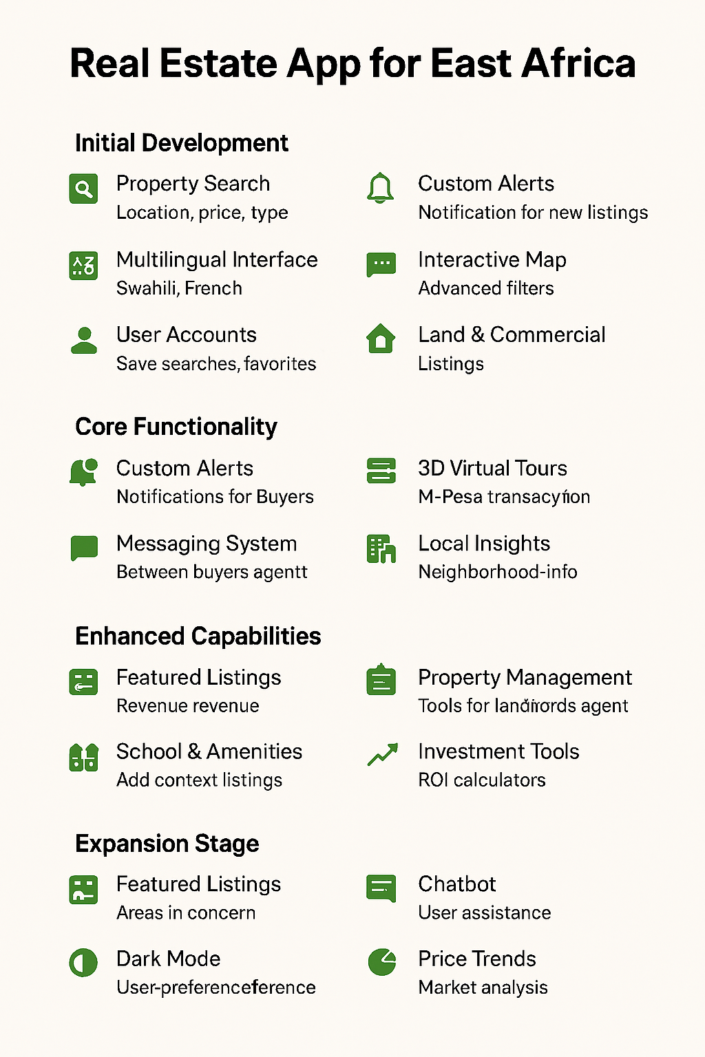

**📍 Feature Roadmap for Your Real Estate App**

**Phase 1: MVP (Minimum Viable Product)**

**Goal**: Launch quickly with essential features.

* **User Registration & Login**
  + Email, phone, or social login
* **Property Listings**
  + Photos, price, location, description
* **Search & Filters**
  + Location, price range, property type
* **Map Integration**
  + Google Maps or OpenStreetMap
* **Contact Agent**
  + In-app messaging or WhatsApp integration
* **Multilingual Support**
  + English, Swahili, French

**Phase 2: Core Expansion**

**Goal**: Improve user experience and agent tools.

* **Favorites & Saved Searches**
* **Push Notifications**
  + New listings, price drops
* **Agent Dashboard**
  + Manage listings, view inquiries
* **Offline Access**
  + Cache listings for low-bandwidth areas
* **Payment Integration**
  + M-Pesa, Airtel Money

**Phase 3: Advanced Features**

**Goal**: Add value and differentiate.

* **Virtual Tours / 3D View**
* **Property Valuation Tool**
* **Loan Calculator**
* **Document Upload & Digital Signatures**
* **Review & Rating System**
* **Analytics Dashboard for Agents**

**🎨 UI Mockup Examples**

Here’s a sample mockup generated for your app concept:

!Real Estate App UI Mockup

You can explore more UI kits and mockups here:

* [Figma Real Estate App UI Kit](https://www.figma.com/community/file/1096718124964343229/real-estate-app-ui-kit)

1

* [Dribbble Real Estate UI Designs](https://dribbble.com/tags/real-estate-ui)

2

* [Envato Real Estate UI Kits](https://elements.envato.com/graphic-templates/product-mockups+ux-and-ui-kits/real+estate+app)

3

**🧩 Open-Source Templates to Kickstart Development**

Here are some excellent GitHub repositories:

1. **Property Web Builder** – Ruby on Rails-based full-featured real estate website

4

1. **MicroRealEstate** – JavaScript-based property management system

4

1. [**RealEstateCRM**](https://github.com/prolinkinfo/RealEstateCRM) – CRM system for agents

5

1. **Streamlit-Geospatial** – Geospatial real estate data visualization

4

1. [**Property4U**](https://marketplace.visualstudio.com/items?itemName=mfahim.Property4U-RealEstate20) – Enterprise-grade solution with APIs

6

Here’s a complete guide to help you **set up your development environment** and **create a compelling pitch deck** for your real estate app tailored to East Africa:

**🛠️ Development Environment Setup Guide**

You can build your app using **Replit**, a browser-based development platform that simplifies setup and deployment:

**Step-by-Step Setup on Replit**

1. **Start a New Workspace**
   * Go to [Replit Real Estate App Builder[1]](https://replit.com/builds/real-estate-app)
   * Describe your app in plain language (e.g., “Create a portal where agents add listings with photos, price, beds, baths, and location. Buyers need search filters, map view, and a ‘save to favorites’ option.”)
2. **Review the Auto-Generated Plan**
   * Replit will return a layout with screens, data models, and a preview of your landing page.
3. **Build & Preview**
   * Replit sets up the project with tools and a live preview.
   * You can test features like search, favorites, and inquiries.
4. **Customize & Iterate**
   * Adjust colors, add tags (e.g., “nearby schools”), or request new features like SMS alerts.
5. **Publish**
   * Launch your app directly from Replit.
   * Connect a custom domain if needed.

**Tips**

* Use Replit’s built-in database for properties, agents, and saved searches.
* Preview on mobile and desktop to ensure responsive design.
* Upload sample listings to guide design and functionality.

**📊 Investor Pitch Deck for East Africa**

Use the **African Pitch Deck Template** from [PitchGrade](https://pitchgrade.com/templates/african-pitch-deck-template) to tailor your presentation to local investors[[2]](https://pitchgrade.com/templates/african-pitch-deck-template).

**Key Slides to Include**

1. **Mission Statement**
   * “Empowering East African communities through accessible property technology.”
2. **Problem**
   * Limited access to verified listings, fragmented agent networks, and low digital adoption.
3. **Solution**
   * A mobile-first platform with verified listings, agent tools, and local payment integration.
4. **Market Opportunity**
   * Real estate market growth in Kenya, Tanzania, Uganda, Rwanda, and Ethiopia.
5. **Product Demo**
   * Screenshots or mockups of your app (search, map view, agent dashboard).
6. **Business Model**
   * Revenue from featured listings, agent subscriptions, and transaction fees.
7. **Traction**
   * Pilot launch stats, partnerships, or community engagement metrics.
8. **Team**
   * Highlight local expertise, tech talent, and advisory board.
9. **Financial Projections**
   * 3-year forecast with user growth, revenue, and break-even timeline.
10. **Social Impact**
    * Affordable housing access, job creation, and digital literacy.
11. **Ask**
    * Funding amount, use of funds (tech, marketing, operations), and expected ROI.

Would you like me to **generate a full pitch deck file** (PDF or PowerPoint) with editable slides and visuals? I can also help you write a compelling **executive summary** or **investor email template**.

**References**

[1] [How to Build a Real Estate App | Replit](https://replit.com/builds/real-estate-app)

[2] [African Pitch Deck Template - PitchGrade](https://pitchgrade.com/templates/african-pitch-deck-template)